Assessment Schedule – 2015

Physics: Demonstrate understanding of electricity and electromagnetism (91173)
 | NØ | N1 | N2 | A3 | A4 | M5 | M6 | E7 | E8
 | No relevant evidence. | Very little Achievement evidence. | Some evidence at Achievement level; partial explanations. | Most evidence at Achievement level. | Nearly all evidence at Achievement level. | Some evidence at Merit level with remainder at Achievement level. | Most evidence at Merit level with some evidence at Achievement level. | Evidence provided for most task, but weak or incomplete at Excellence level. | Evidence provided for most tasks and Excellence level is accurate and full.
Q 1,4 | No response; no relevant evidence. | 1a | 2a | 3a | 4a | 2m + 1a | 2m + 2a | 2m + 1e | 1e + 2m + 1a
Q 2,3 | No response; no relevant evidence. | some evidence | 1a | 2a | 3a | 2m | 2m + 1a | 1e+1m+1a | 1e + 2m

Evidence Statement
Q | Evidence | Achievement | Merit | Excellence
ONE  (a) | 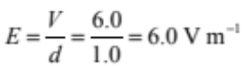 | Correct answer.
(b) | The force on an electron is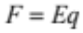  The charge is constant, so if the electric field strength is constant, then the force will be constant. | Constant force. | Constant force AND reason.
(c) | 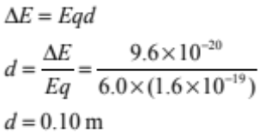 | Correct equation and re-arrangement. | Correct answer.
(d) | 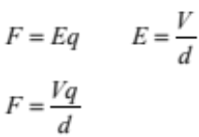  If he adds another battery in series, this will double the voltage.  If he halves the wire length, this will double the electric field strength.  Both together will cause the force to be 4 times larger. | Recognises the voltage will double by adding another battery in series.  OR  Recognises the electric field strength will double by halving the length of wire. | Recognises the voltage will double by adding another battery in series.  AND  Recognises the electric field strength will double by halving the length of wire. | Complete answer linking ideas to show that force increases four times.

TWO  (a) | Down. | Correct answer.
(b) | 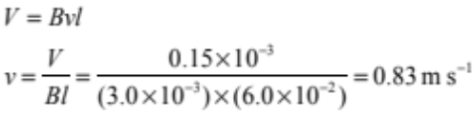 | Correct except for wrong length OR wrong unit conversion. | Correct answer.
(c) | 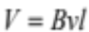  So if the speed doubles, the voltage doubles.  Assuming the resistance is constant, this will cause the current to double. | Current doubles. | Correct answer and reason.
(d) | The current is zero.  Both sides of the loop are cutting across the magnetic field.  Both sides of the loop have the same voltage induced.  One voltage pushes the charges clockwise. The other voltage pushes the charge anticlockwise. The net voltage is zero (OR voltages cancel). | The current is zero. | The current is zero AND a reason (e.g. both wires are cutting the field and have an induced voltage). | Correct answer showing understanding of connection between concepts.

THREE  (a) | 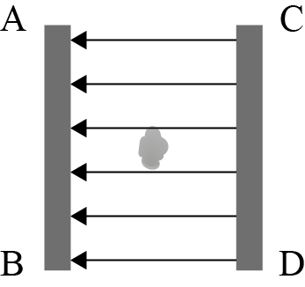  Field is uniform.  Field is directed right to left. | Correct direction, and uniform spacing.
(b) | 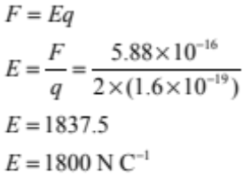 | Correct except for charge. | Correct answer.
(c) | The force is zero.  A charged particle experiences a force due to a magnetic field only when it is cutting across the field. | The force is zero. | Correct answer and reason.
(d) | 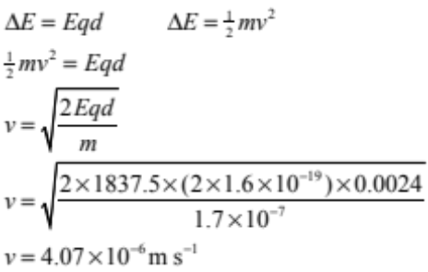 | Attempts to link both equations. | Links equations but mis-calculation. | Correct answer and working.

FOUR  (a) | 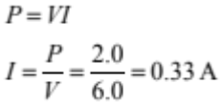 | Correct answer.
(b) | Voltage across resistor = 9.0 – 6.0 = 3.0 V  Current through resistor = 2 × 0.33 = 0.66 A  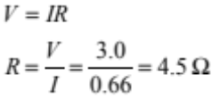 | Correct voltage OR current. | Correct answer and working.
(c) | The lamps are in parallel, so removing one lamp increases total resistance.  The supply voltage is the same, so if the total resistance increases, total current will decrease. | Current decreases. | Correct answer and reason.
(d) | Resistance of parallel lamps is:  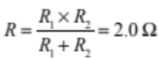  Total resistance = 6.0 Ω  Total current is 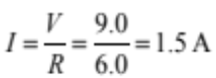  Resistor voltage is 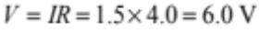 | Correct total resistance. | Correct total resistance and current. | Correct answer and working.

Cut Scores
Not Achieved | Achievement | Achievement with Merit | Achievement with Excellence
0 – 9 | 10 – 18 | 19 – 25 | 26 – 32

